Creating RDS

1)Click on create Database

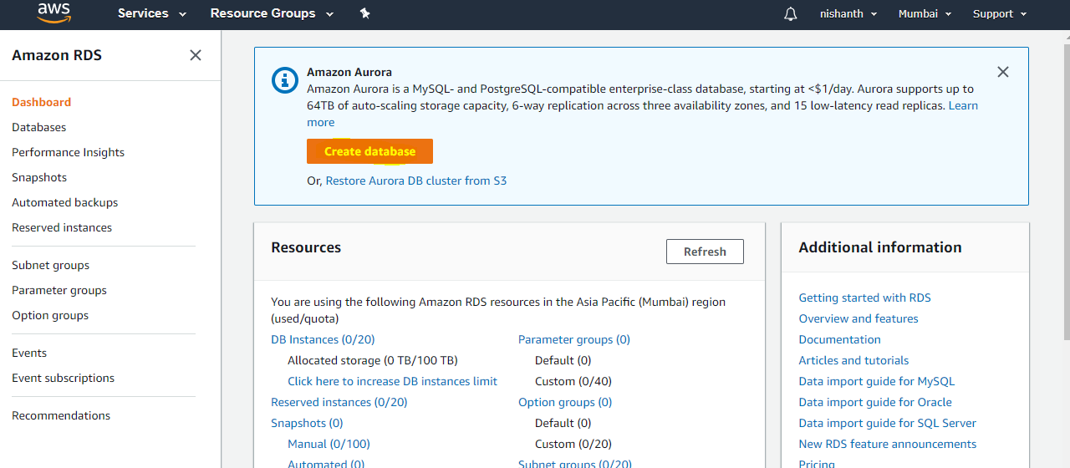

Switch to original interface

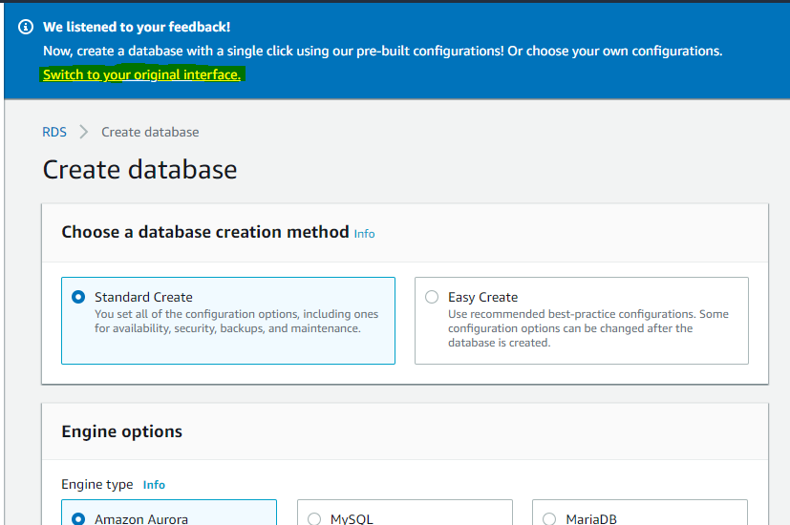

Where all Database Engine will be present in RDS Database Dashboard.

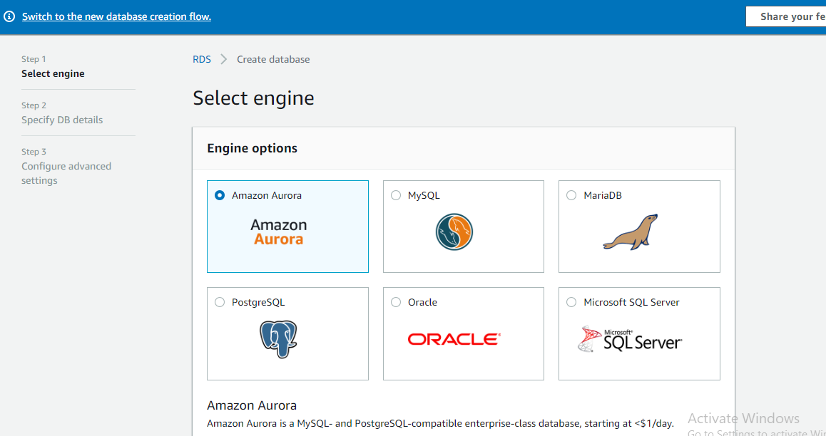

Enable only free tier RDS Engine

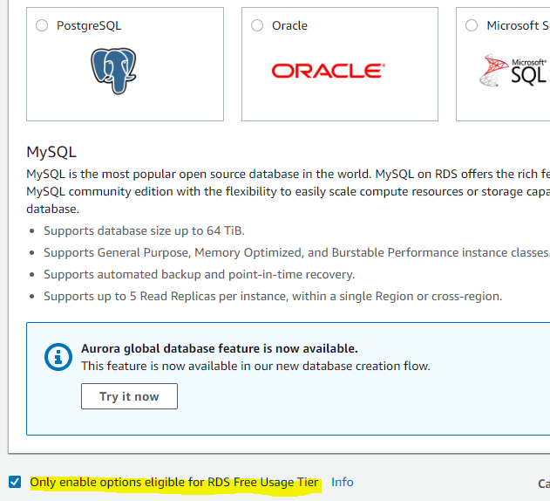

Select Sql Engine and click on next

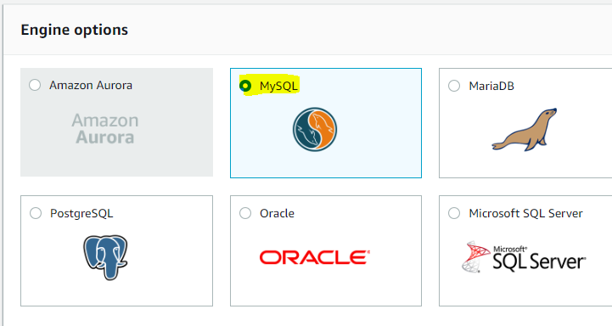

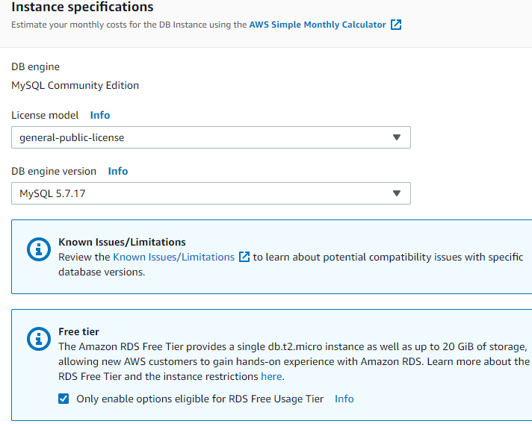

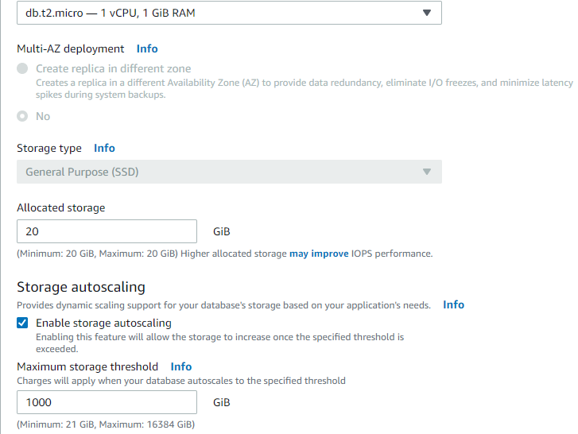

Set the database details

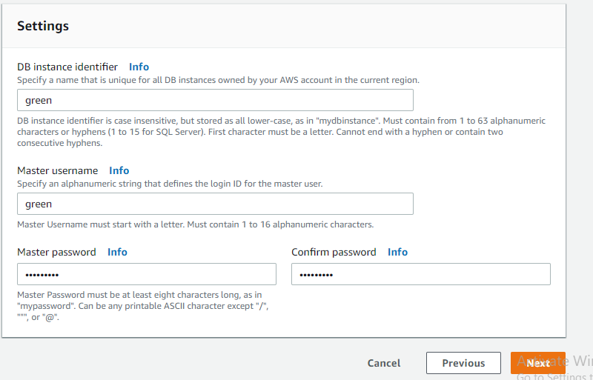

Configure the advance detail

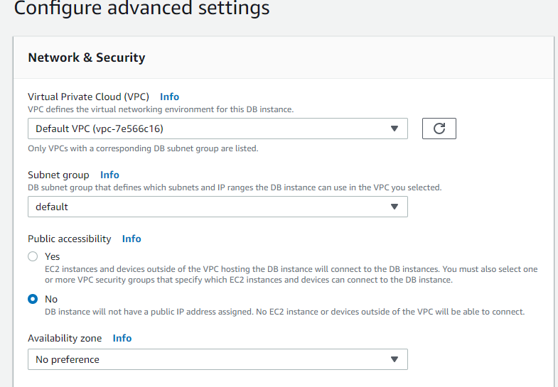

Select default VPC setting

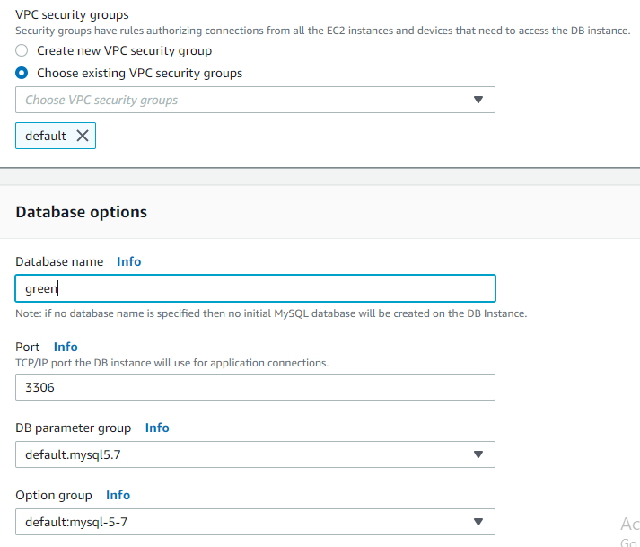

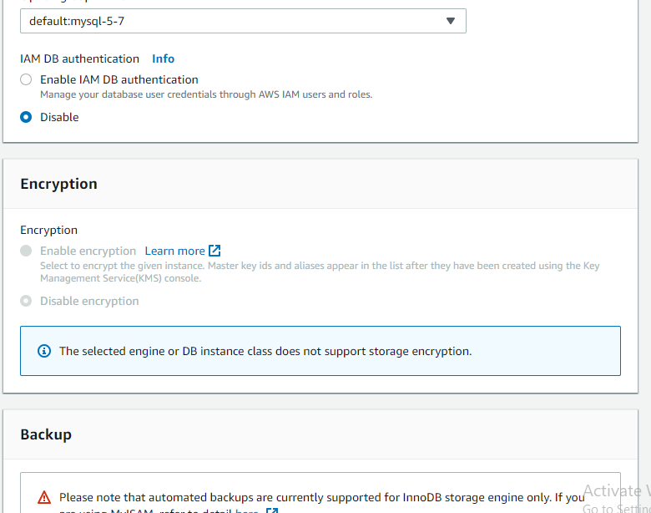

Select Backup if you required for your database and disable the maintainence window .Disable Deletion Protection also for database creation.

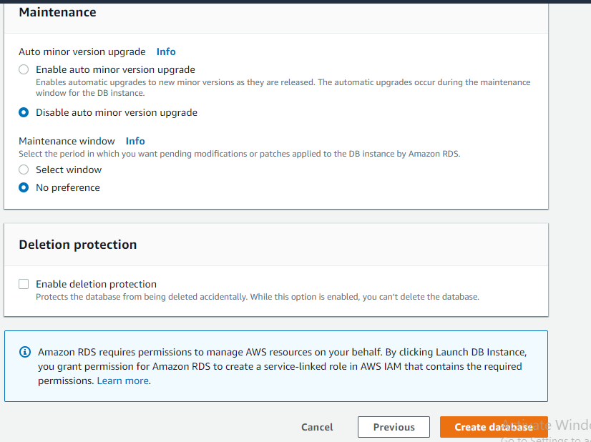

Launch Ec2 instance to get the output of DB.

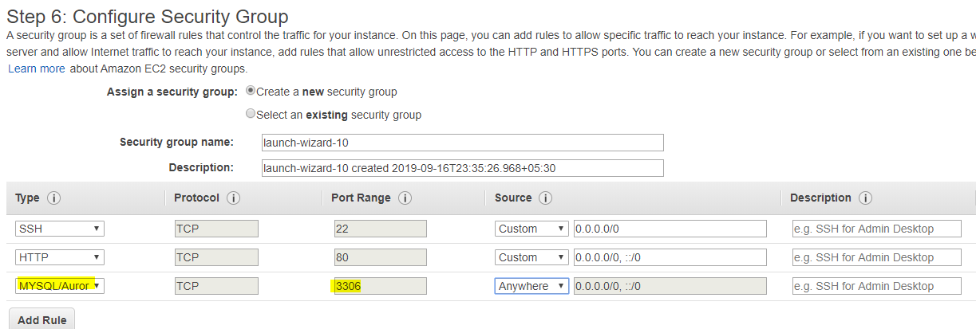

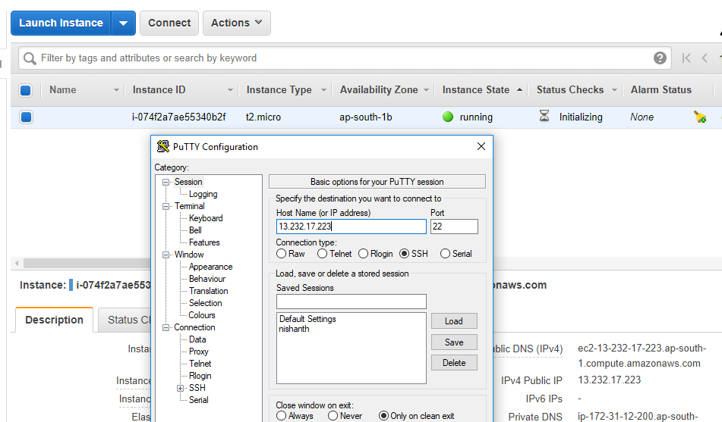

Login to instance and install mariadb package to install database

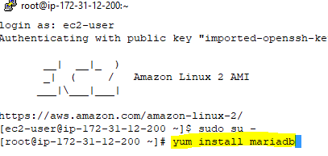

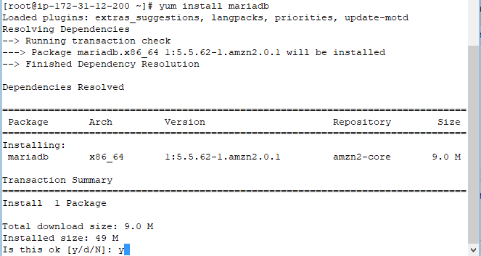

Click yes to install mariadb

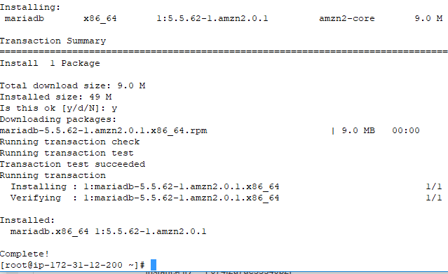

Then go to RDS and take the Endpoint from RDS and execute in Ec2 instance. Check the DB status once it become available endpoint will be available to use.

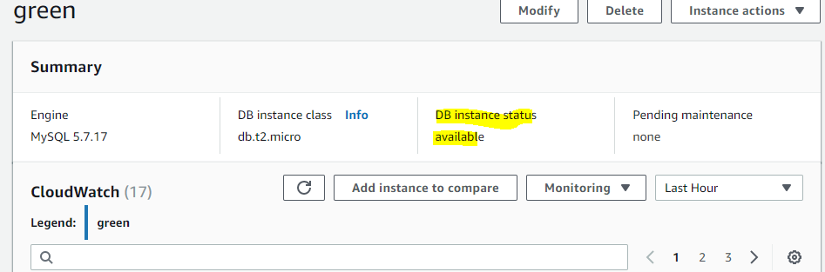

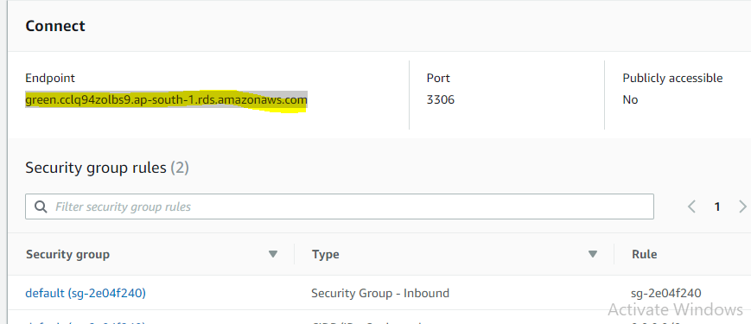

Then Execute the command “mysql –h endpoint –P 3306 –u (username) –p then give enter to feed the password then you can able to access the DB.

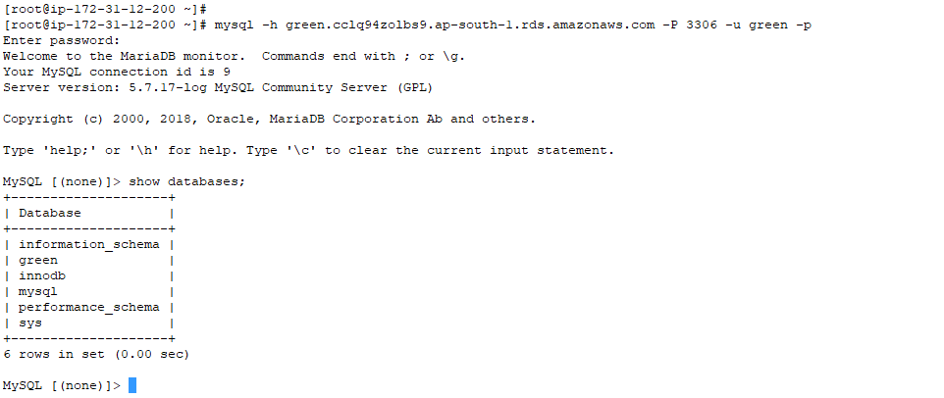

While deleting go to dashboard and select the RDS ->Action->Delete

It will ask you whether you can backup and snapshot.

